Name: _______________________________________________ Date: _______________________________

How do Living Things Provide Evidence for Evolution
Homologous Structures

Body parts in different organisms that have the same basic structure are called homologous structures. By comparing homologous structures, biologists can determine how organisms might be related. Homologous structures may not necessarily have the same function, but they are similar in structure (such as bone location and number of bones). The presence of homologous structures suggests that organisms evolved from a common ancestor.
Analogous structures have the same function; but are very different in structure.

- Compare the meaning of the terms “homologous” and “analogous”:
_________________________________________________________________________________________________________________________________________________________________________________________________________.

Figure 1: Homologous Structures

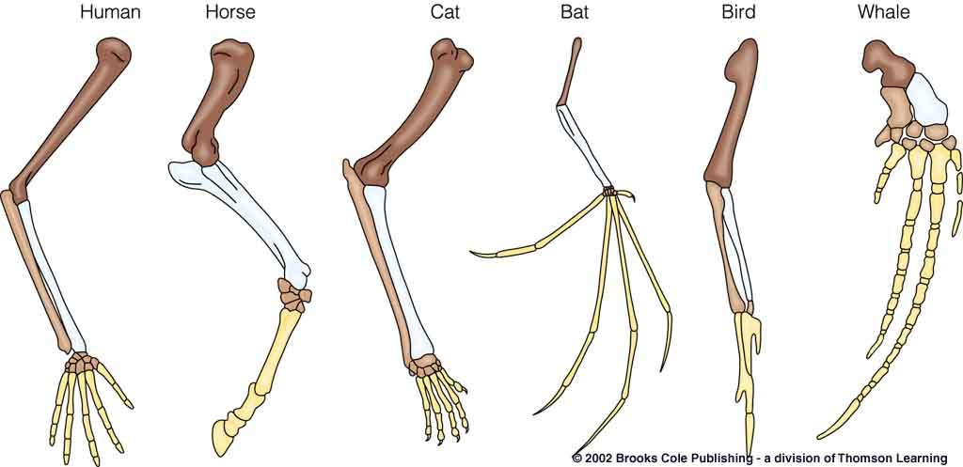

Figure 2: Analogous Structures
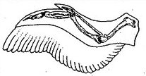
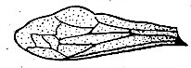

Bird wing
Insect wing

© 2013 Vanessa Jason Biology Roots

© 2013 Vanessa Jason Biology Roots

© 2013 Vanessa Jason Biology Roots

2. Data Table 1: Homologous Structures
Use Figure 1 to complete the table:
Organism | Body Part | Function
Human
Whale
Cat
Bat
Bird
Alligator

- How are all the body parts in Figure 1 alike? ____________________________________________________ ________________________________________________________________________________________________________.

- How are they different? ___________________________________________________________________________
_______________________________________________________________________________________________________.

5. Data table 2: Analogous Structures
Use Figure 2 to complete the table:
Organism | Body Part | Function

Analysis and Conclusions

- Why are the structures in Figure 1 homologous structures? (*note* the definition of homologous structures might be used to help support your answer, but it should not serve as the answer itself. Really analyze the bones- become an expert!). ___________________________________________________________________________________________________________________________________________________________________________________________________________________________________________________________________________________________________________________________________________________________________________________________________________________.

© 2013 Vanessa Jason Biology Roots

© 2013 Vanessa Jason Biology Roots

7. Why are the structures in Figure 2 analogous structures? _______________________________________________________________________________________________________ _________________________________________________________________.

8. Do the wings of birds and insects suggest an evolutionary relationship? How do you know? ________________________________________________________________________________________________________________________________________________________________________________________________________________________________________________________________________________________________________________.

Vestigial Structures

Vestigial structures are body parts that are found in living organisms, but have no purpose. The question then arises, why are these structures present? Biologists find that these structures may suggest an evolutionary past. For example, snakes have reduced leg bones attached to their pelvic girdle. This suggests that snakes may have evolved from similar animals that indeed had legs and walked.

9. Thinking critically: examine the examples of vestigial structures in the table below. Determine what each vestigial structure may suggest about the organism’s evolutionary past.

Animal | Vestigial Structure | What might this tell us about its evolutionary past?
Ostrich | Wings
Whale | Pelvic limbs (leg bones)
Human | Coccyx (tail bone)

10. How do vestigial structures provide evidence of an organism’s evolutionary past? ______________________________________________________________________________________________________________________________________________________________________________________________________________________________________________________________________________________________________________________________________________________________________________________________________________________________.

11. How are homologous and vestigial structures alike? How are they different? ___________________________________________________________________________________________________________________________________________________________________________________________________________________________________________________________________________________________________________________________________________________________________________________________________________________________________.
© 2013 Vanessa Jason Biology Roots

